Biblionasium
https://www.youtube.com/watch?v=jIIzjF2tGpw
- Open the school website and click on Resource Centre.
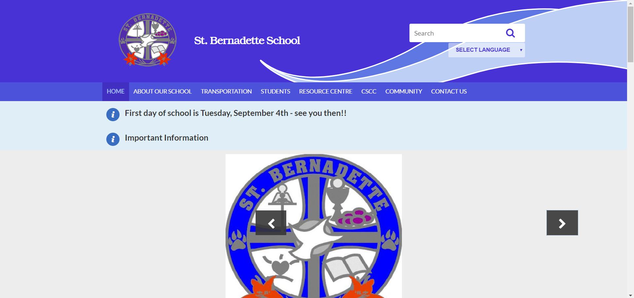
- Click on Library Catalogue – it will take you to Destiny:
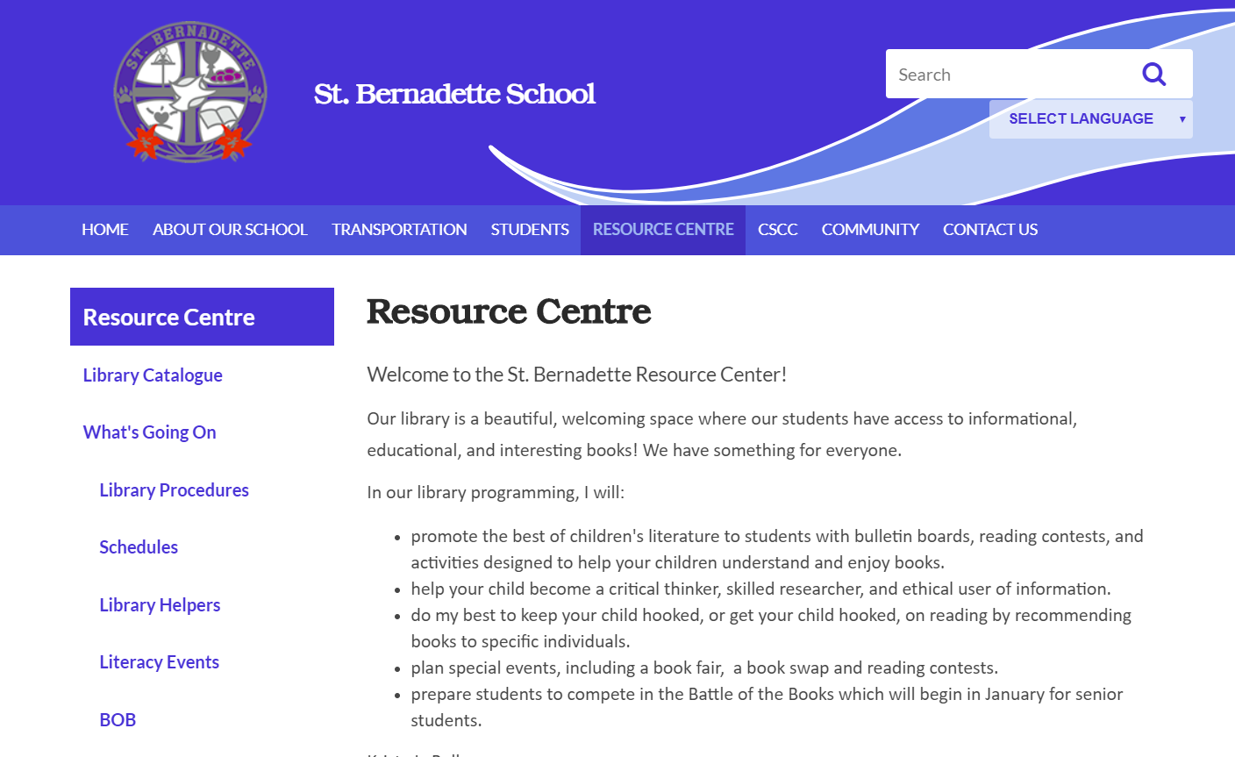
- When in Destiny - select your school.
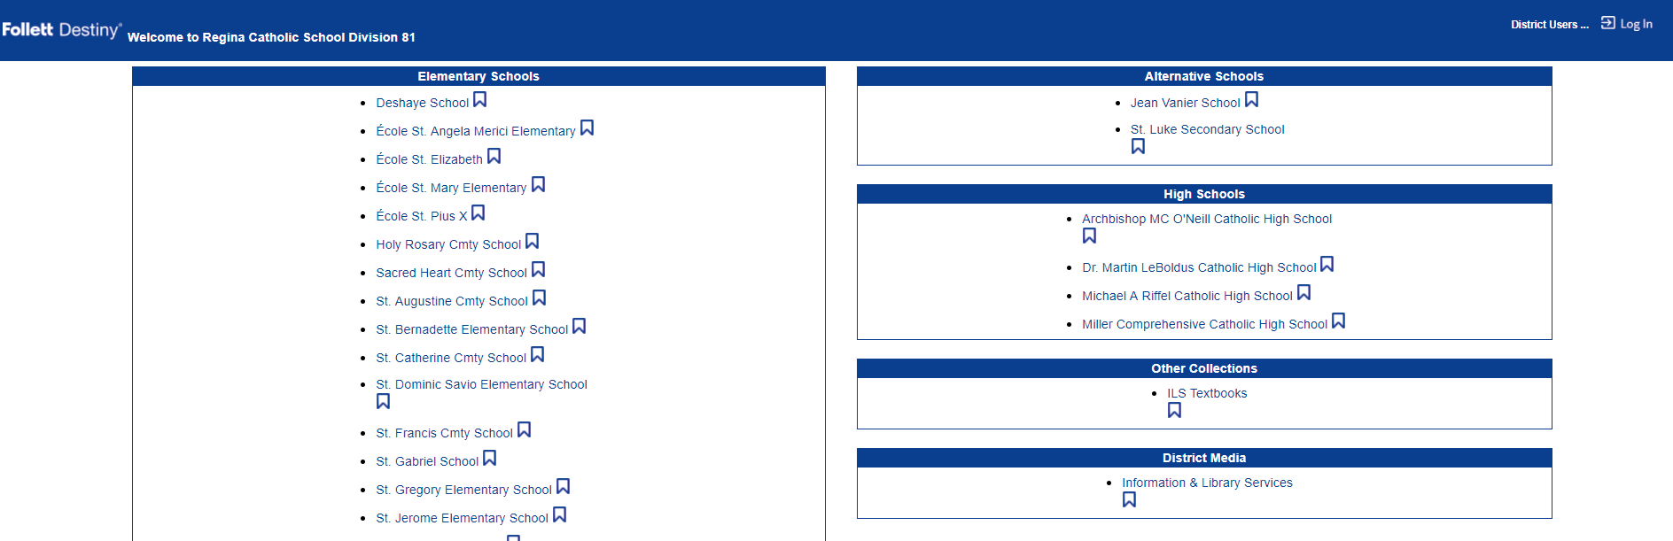

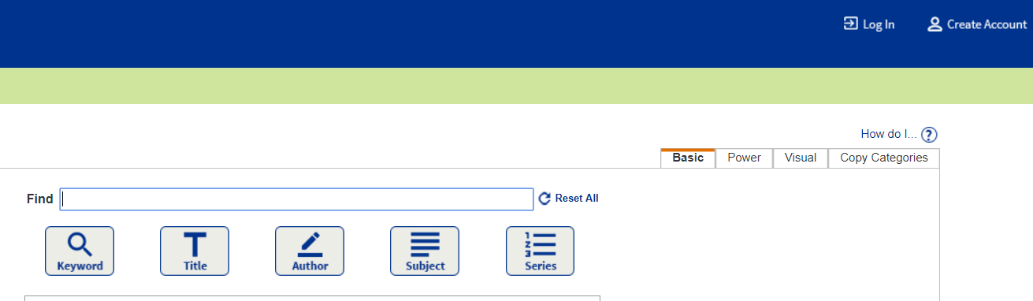
- Click ‘Log in’ in the top right.

- Click anywhere in the grey SSO box. If this is not available, select “Log in using Destiny” below the grey box.
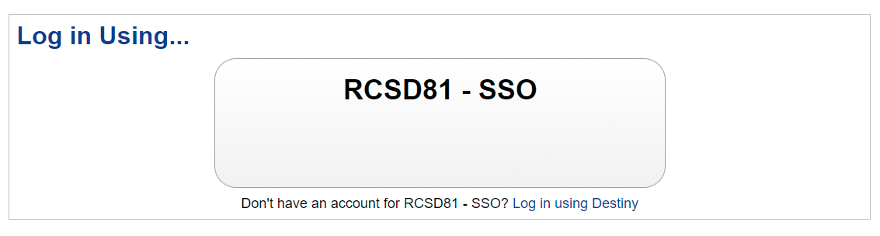

- When SSO is not available: log in with the same user ID and password used to log into the computer.
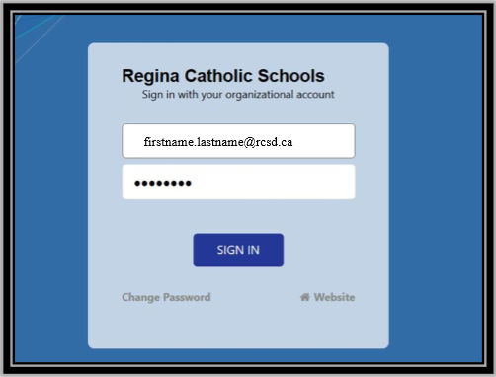

- Select the three lines in the top left. The Destiny Discover menu will open. Select Biblionasium.
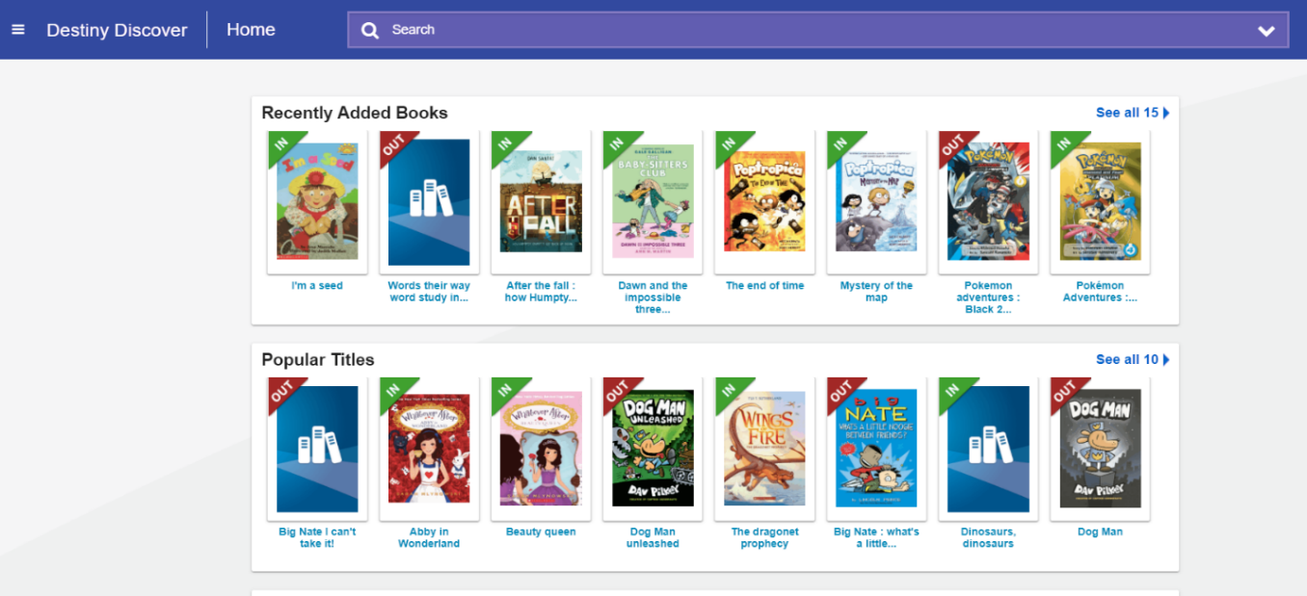
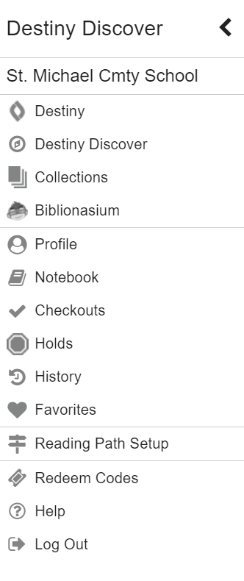

- Once you are logged in the home screen will look like this:
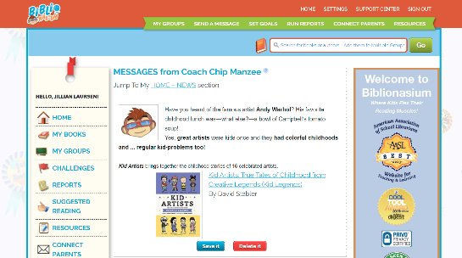

Biblionasium: Log In using an Android Device
- Locate the “Biblionasium” icon on the home screen.
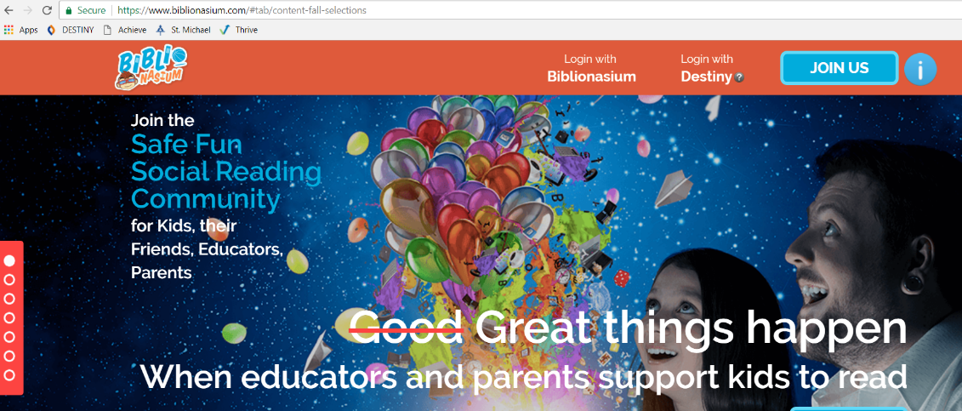
- Select “Log in with Destiny.”

- Select your ‘Location” and “School.”
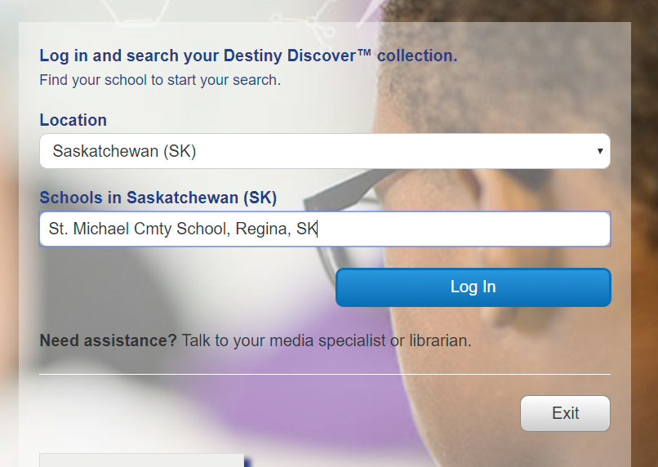

- Once you are logged in the home screen will look like this:
